Some Books in Peoplese Language

Click on cover for book description on amazon.com

Some titles may be temporarily unavailable.

[](https://a.co/d/0bBrgg8) [](https://a.co/d/5s1qU8q) [](https://a.co/d/b4dUuys) [](https://a.co/d/dzz1g3G)

[](https://a.co/d/cXtJU7I) [](https://a.co/d/hoPjCqa) [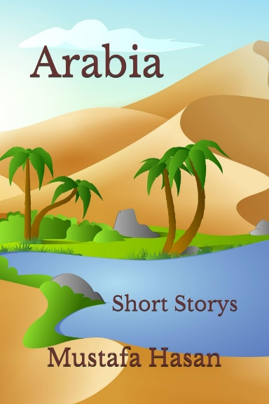](https://a.co/d/3LIC2AZ) [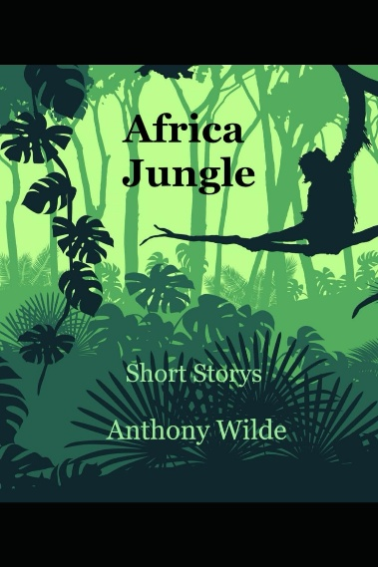](https://a.co/d/4NDFOVF)

[](https://a.co/d/aiw9VPX) [](https://a.co/d/h21sOh7) [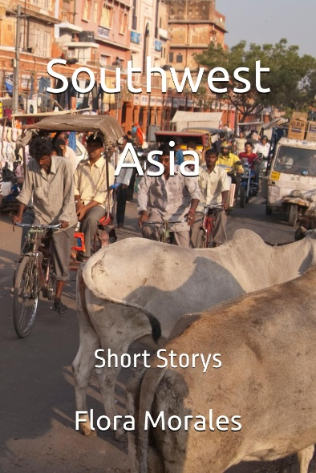](https://a.co/d/fzGOME1) [](https://a.co/d/0Y5r0sP)

[](https://a.co/d/d3FpKDH)  [](https://a.co/d/2W4IB4K) [](https://a.co/d/hlQDmar)

[](https://a.co/d/cTYUJqv) [](https://a.co/d/6EwHGMW) [](https://a.co/d/6v7JYKK) [](https://a.co/d/hKTkGdG)

[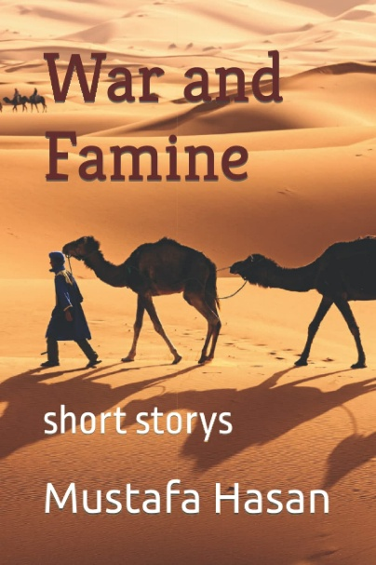](https://a.co/d/3LTknmn) [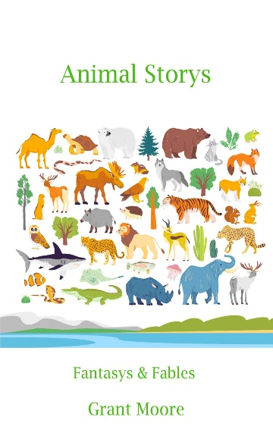](https://a.co/d/24pezg8) [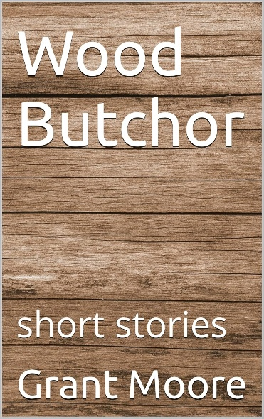](https://a.co/d/7QxcDbt) [](https://a.co/d/cJUijlb)